

**ANONYMOUS BOT**

Contents

1 Purpose 2

2 User Login - CAPTCHA 2

3 Bot hit through API 4

4 Jmeter Testing 5

# Purpose

The purpose of this document is to provide an overview of Anonymous bot hit and user login using captcha.

# User Login - CAPTCHA

The users can able to login the screen by entering valid ***captcha*** displaying on the login screen.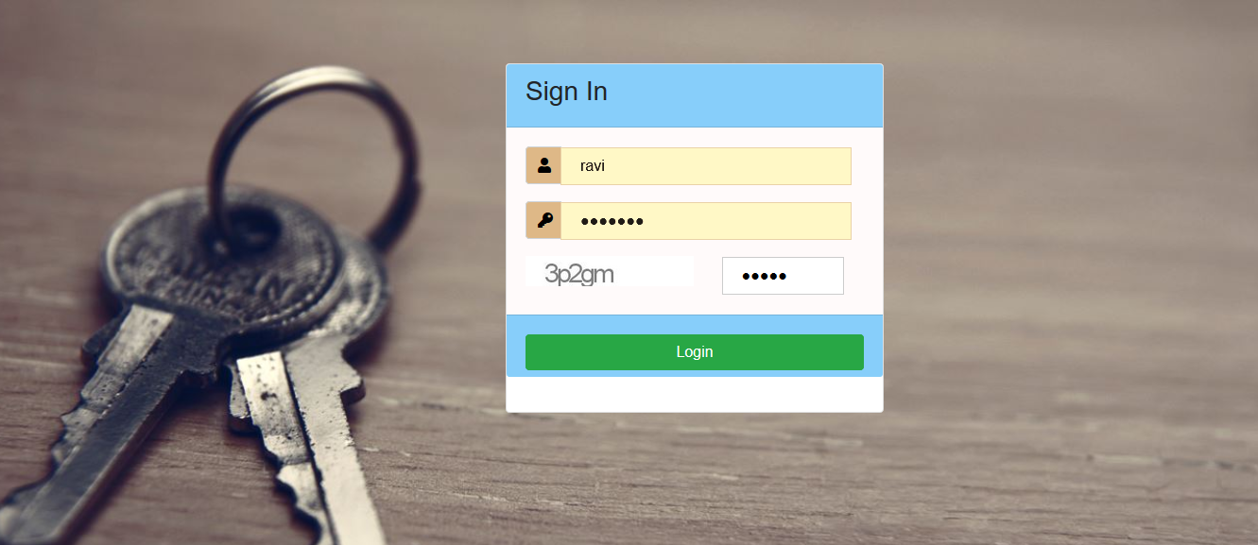

After successful login users can be navigated to the success screen.



If the entered captcha is not valid, then an error message ***“Invalid captcha*** ***“*** will be displayed below the captcha field.

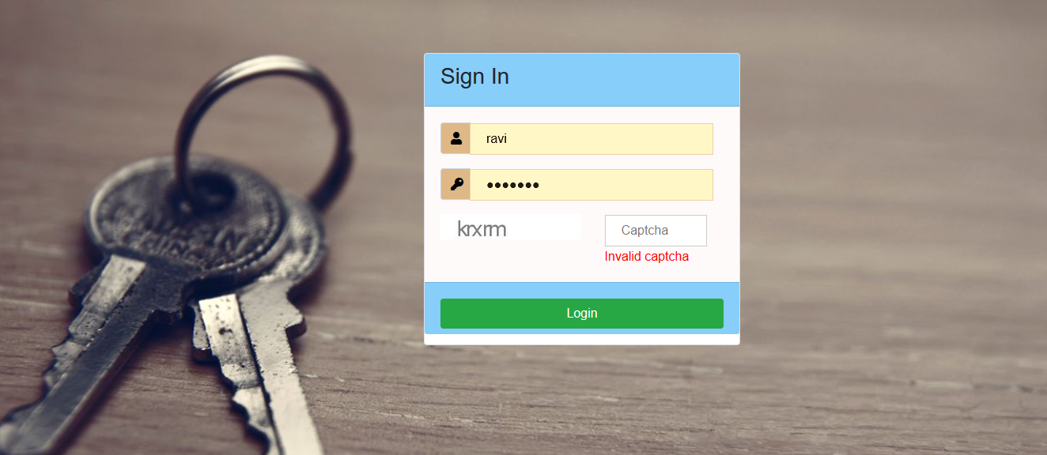

**Flow Diagram:**

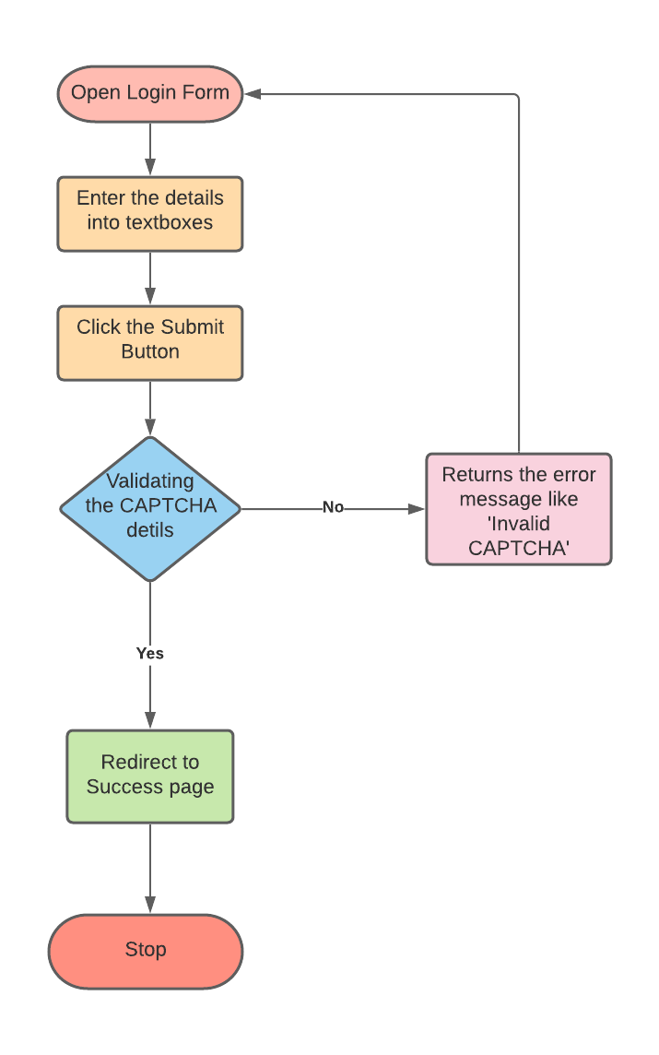

# Bot hit through API

The bots are filtered through API by validating hit counts per second. This API accepts five hits per second(Configurable). If API receives hits more than five per second, then the requests after 5th one will be treated with response code ***429*** and return the response “Too Many Requests”.

**Flow Diagram:**

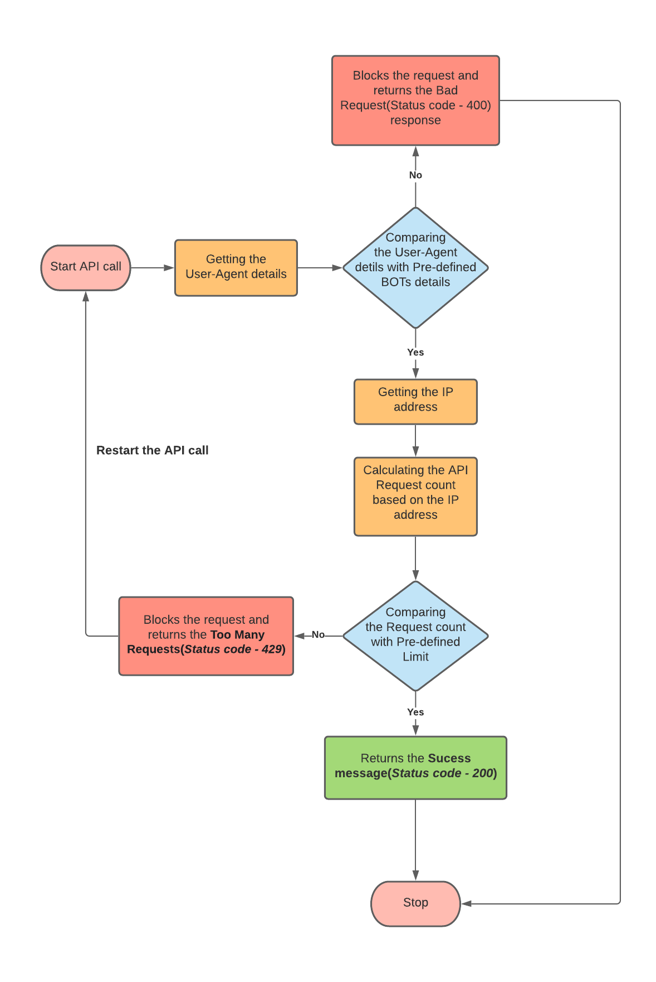

# Jmeter Testing

1. A new thread group could be created to set the maximum allowed request counts and the request period.

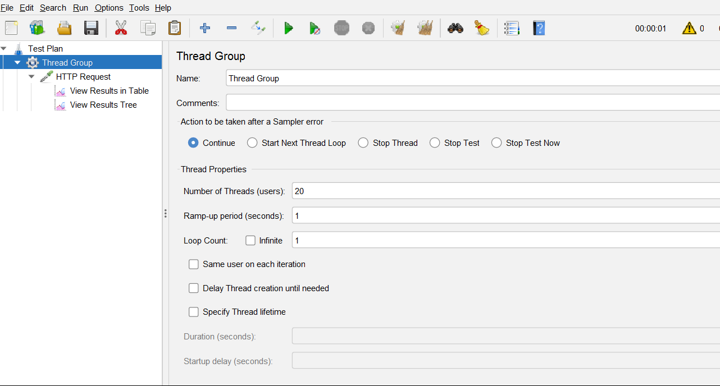

1. An HTTP Request is created to set the API path details and credentials to hit the API request

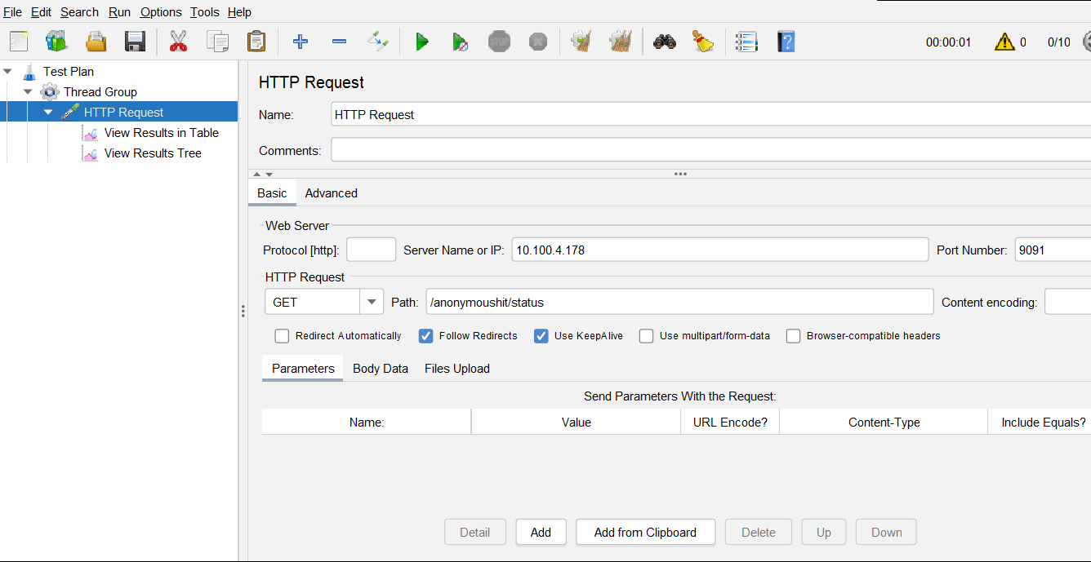

1. A listener is created to view the output/Result of configured API in table format. In the below table, it is very clear that request between 1 & 5 are successful where as others are failed.

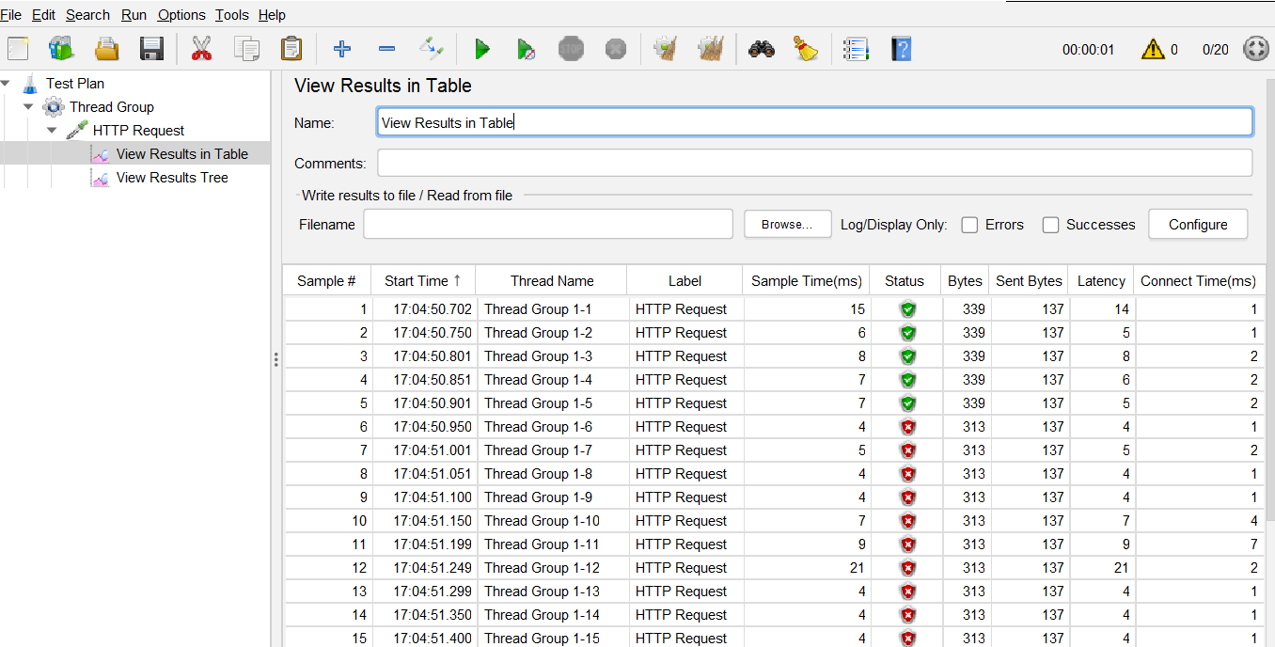

1. This listener is used to view the detailed result of requests. The first five requests show the response code as 200 and requested successfully.

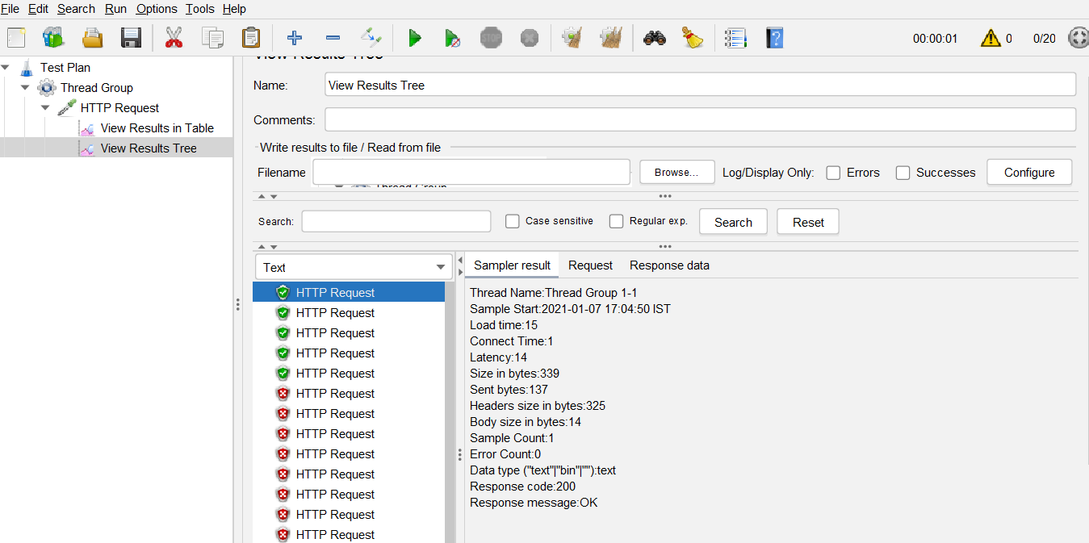

1. This listener is used to view the detailed result of requests. The requests after five shows the response code as 429 and displaying the response message as “Too Many Requests”.

